Infrared thermal sensors

**I - Definition**

An infrared thermometer is a thermometer which infers temperature from a portion of the thermal radiation sometimes called black-body radiation emitted by the object being measured. They are sometimes called laser thermometers as a laser is used to help aim the thermometer, or non-contact thermometers or temperature guns, to describe the device's ability to measure temperature from a distance. By knowing the amount of infrared energy emitted by the object and its emissivity, the object's temperature can often be determined within a certain range of its actual temperature. Infrared thermometers are a subset of devices known as "thermal radiation thermometers".

**II - Operation mode**

The infra-red thermometer is composed of a lens, an infra-red detector, and an electronic board. The lens is like an eye, through which thermal radiations goes to reach the radiation sensitive sensor, where it’s converted to a useful voltage.

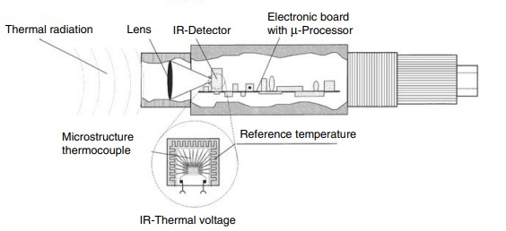

Fig 1: Design principle of an infrared measuring (IR) system

Every body with a temperature emits infra-red a function of its temperature (called self-radiation). The reason for this radiation is the internal molecular movement, which produces charges motion and an electromagnetic radiation (protons) is emitted. These protons move at the speed of light and behave according to the Laws of Optics. The thermal radiation extends from 0.7 µm to approximately 1000 µm.

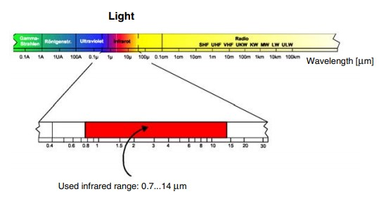

Fig 2: The electromagnetic spectrum, with the usable infrared range

Infrared measurement technology is based on the blackbody radiation curve. Infra-red thermometers are designed so that as much energy as possible from an object can be used for evaluation.  
Another important parameter is he radiation characteristic of some materials, those with so called non-graybody radiation (glass, metals and plastic foils). Fig. 3 shows curves for ideal blackbody radiation. Many bodies emit less radiation at the same temperature. The relationship of the real radiation value to blackbody radiation is known as the emissivity e, which has a maximum value of 1 (body corresponds to an ideal blackbody) and a minimum value of 0. Bodies, whose emissivity value is less than 1, are called graybody radiators. Bodies whose emissivity value is also a function of the temperature and wavelength, are called non-graybody radiators.

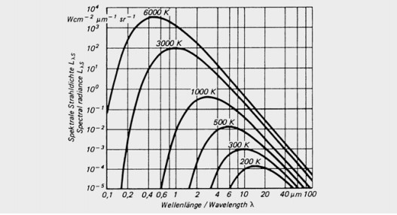

Fig 3: Blackbody radiation curve as a function of the temperature

**III – Applications**

**Applications in the electrical fields:**

Infrared non-contact thermometers are well-suited for: Finding Hotspots, Preventing Arcing and Insulation Damage, Locating Grounds in Circuits, Pinpointing Sources of Nuisance Tripping, Spotting Energy Loss Sources, Protecting Electric Motors, Checking Transformers, Measure Temperature from a Safe Distance, Locate Wire Damage

**Motor bearings:** Heat is generated when bearings break down, causing the motor to vibrate and become off centered. Scanning bearing temperatures with an infrared thermometer allows the maintenance engineer to detect hot spots and schedule repairs or replacements before the problem leads to an equipment failure.

**Transformers:** Maximum permissible operating temperatures are usually listed on the transformer. The windings of air-cooled units can be measured directly with an infrared thermometer to verify overall temperature. Any hot spots indicate winding flaws.

**Uninterruptible power supplies:** DC battery connections are susceptible to loosening and corrosion, which can create excess heat. Hot localized connections in the UPS output filters can be identified with an infrared thermometer. A cold spot may indicate an open dc filter circuit

**Applications in other fields:**

* Metal and alloy production (melting, casting, rolling, hardening, forging, annealing, welding, drawing, sintering)
* Cement and lime furnaces, rotary furnaces
* Fire chamber measurements in power plants and waste incineration furnaces
* Glass industry (glass crucibles, feeders, float glass line)
* Food and beverage industry (freezing, baking, frying, sterilizing, filling, packaging)
* Textile industry (drying, fibers)
* Paper industry (coating, drying)
* Plastics (casting, forming, granulating)
* Automotive industry
* Maintenance and service

**IV - Price Comparison**

3 of the best rated industrial thermal sensors, their characteristics and prices:

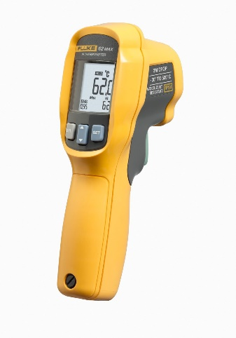Fluke 62 Max

Price: 99 USD

Characteristics:

* Measures temperature from 30 to +500 degrees C (-22 to +932 degrees F) with an accuracy of + or 1.5 degree C or + or 1.5 percent of the reading from 0 to 500 degrees C
* 10:1 infrared distance to spot ratio with laser sighting for pinpointing the measurement area
* Displays the minimum, the maximum, the difference between the two temperatures, and the average temperatures
* Certified IP54 for protection against dust and splashing liquid
* IP54 rated for dust and water resistance
* Precise laser technology makes for more accurate and repeatable measurements

# Etekcity 1022D Dual Laser

Price: 25 USD

Characteristics:

* BETTER ACCURACY+ ADJUSTABLE EMISSIVITY: The distance to spot ratio is 12: 1
* DUAL LASER + TARGET QUICKER: Dual-laser targeting technology makes it easier to visualize the area being measured by an IR thermometer, resulting in higher precision versus a single laser; Measure surface temperature ranging from -58°F to 1022°F/ -50°C to 550°C; Response time: ≤500Ms
* VERSATILE DESIGN: Infrared technology makes this thermometer handy to measure the surface temperature of various objects especially temperatures above boiling points and below freezing points; Use it when you are cooking and barbequing, performing auto maintenance, doing home repairs, and a host of other tasks

# Amprobe IR-730

Price: 130 USD

Characteristics:

* Measure temperatures quickly and accurately without having to touch the object using the laser pointer. Updates four times per second.
* Typical uses include cooking and food preparation, outdoor grilling, automotive diagnostics, HVAC service, electrical troubleshooting, industrial maintenance, fire prevention, home thermal leak detection, and hobbyist applications.
* Take your temperature easily within seconds. Safe for all ages!
* Save money on energy costs by locating air leaks in doors and windows
* Measures from -26°F to 2282°F (-32°C to 1250°C); accuracy +/- 1.8% (typical)
* Calibrate new cooking appliances such as an oven, stove-top or grill
* Test temperature output of heating and cooling systems
* Adjustable emissivity from 0.10 to 1.00

2